Problem 1

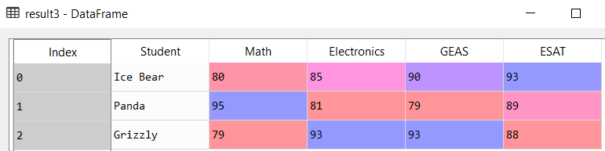

*Result3 is made by merging “result” which contains variables a and b with “result2” which contains variables c and d.*

Problem 2

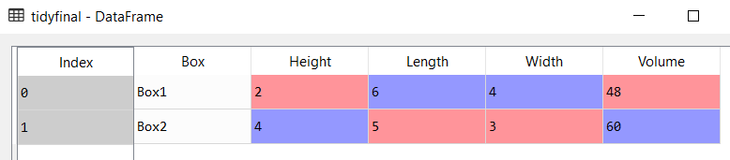

*Box1 and Box2 were appended to create the messy dataframe and was pivoted to make the tidy dataframe, then Volume was created to be added and merged to tidyfinal.*